**Practicing RPA tools with managing Variables in an Arguments Panel**

1. Print a message using message box activity in UiPath Studio.
2. Perform string concatenation with necessary activities in Uipath Studio.
3. Identify length of a STRING with necessary activities in Uipath Studio.

**A**

**UiPath Studio Flow:**

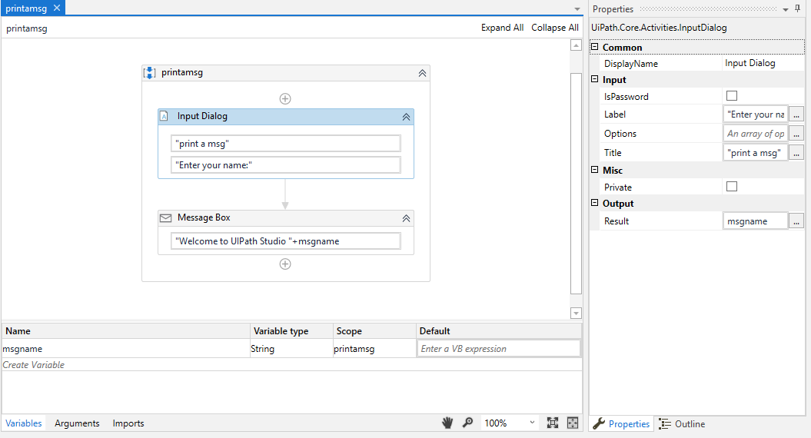

**OUTPUT:**

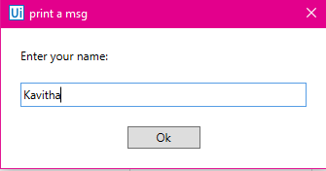

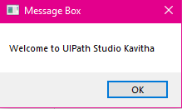

**B).**

**UiPath Studio Flow:**

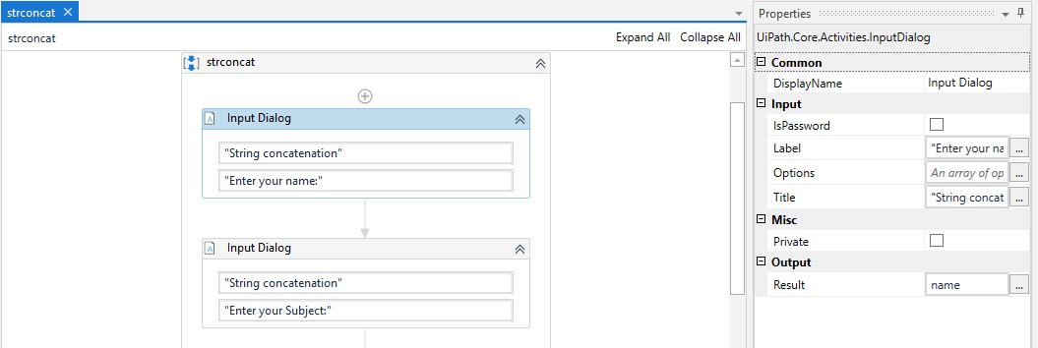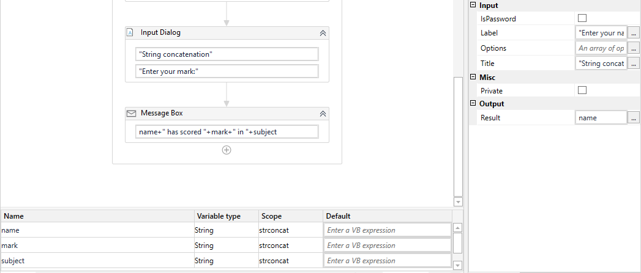**OUTPUT:**

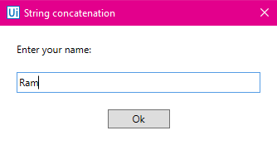 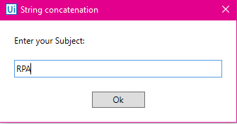

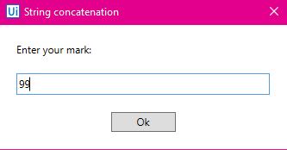

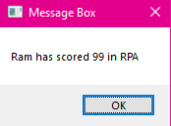

**C**

**UiPath Studio Flow:**

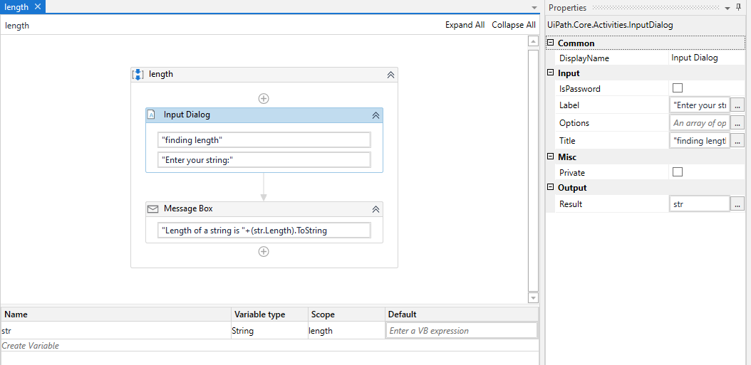

**OUTPUT:**

